

**ICS2014 : Computer Organization and Architecture**

**Assignment #2**

**121455 OLYVIAH AMWOMA**

**120174 CYNTHIA GICHUKI**

**121759 SHAMSA ABDULLAHI**

**122181 FREDRICK ROGATO**

1. **A**

Here user inputs number to be converted.

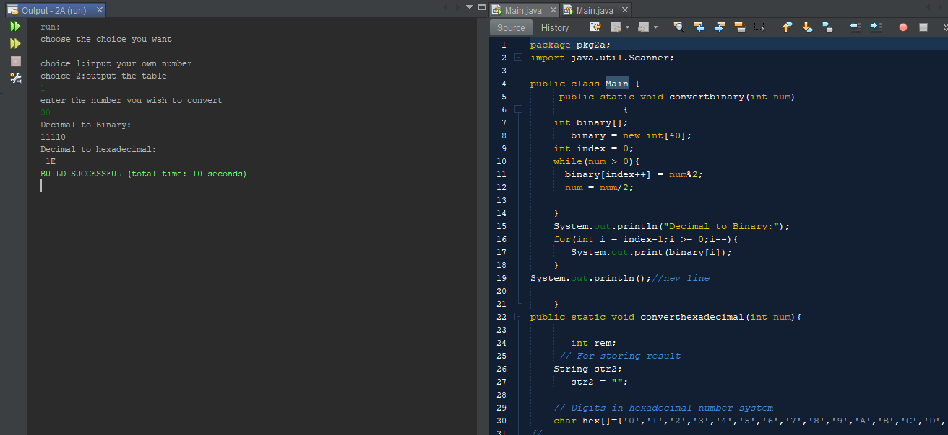

Here the user prompts the program to generate the table.

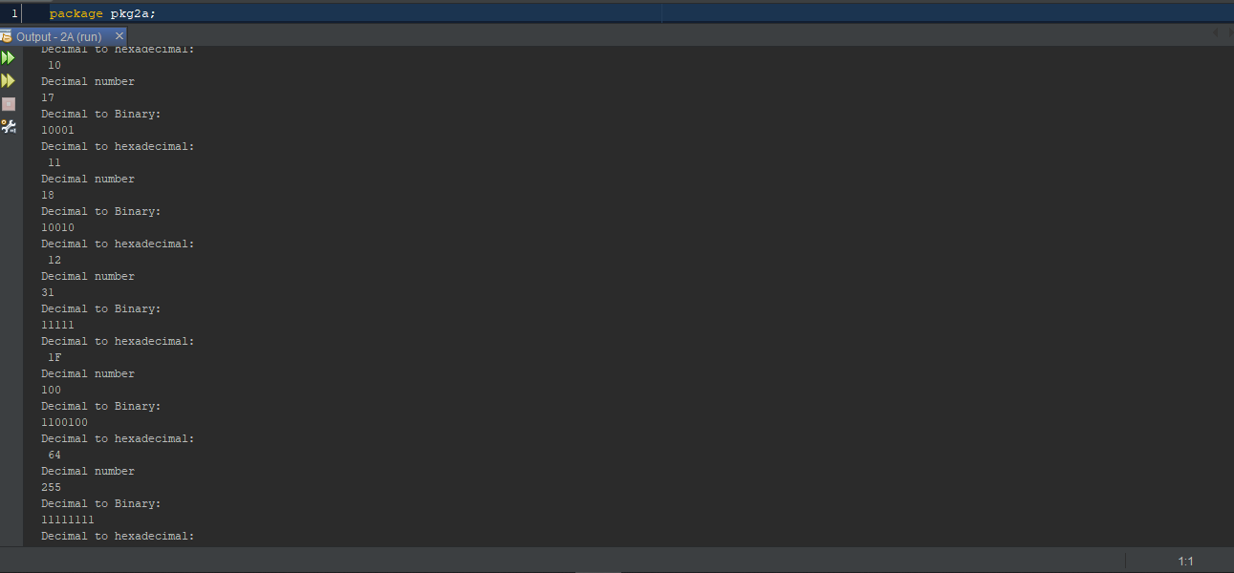

1. **B**

Here the user enters double number to be converted and the output is shown as exact or approximate.

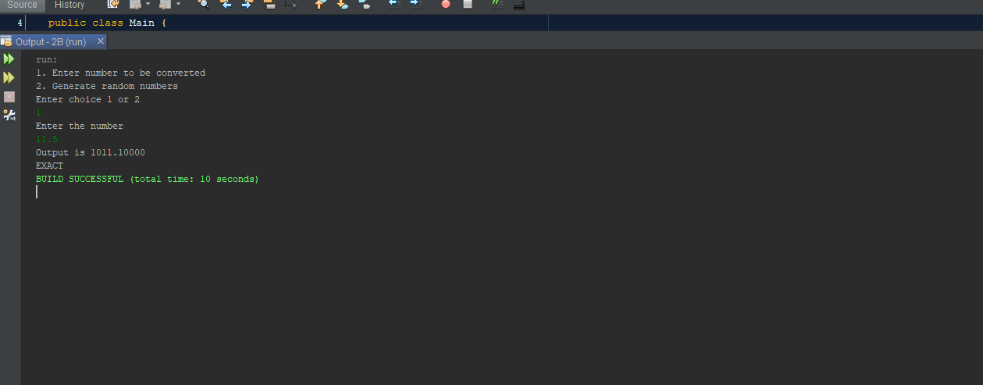

Here random values are generated and converted to binary and to 5 decimal places.

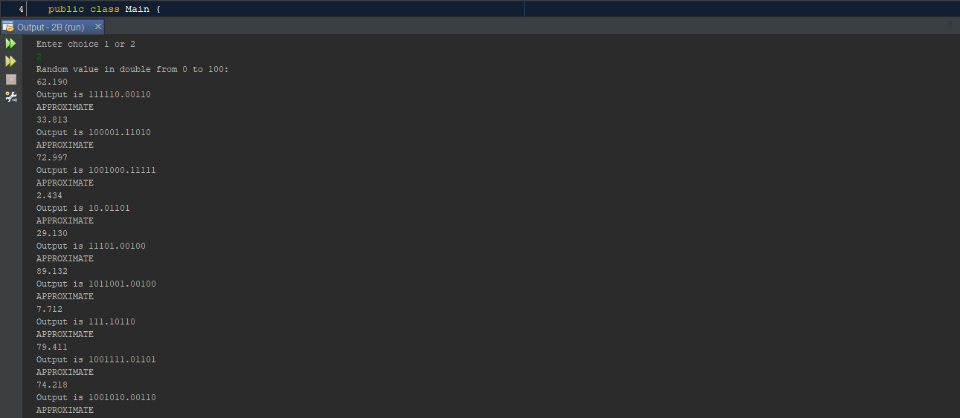

**References**

N/A